DRAFT Technical Memorandum |  | 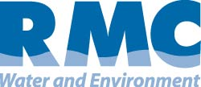

Merced Integrated Regional Water Management Plan
Subject: | Plan Inventory Technical Memorandum
Prepared For: | Merced Integrated Regional Water Management Plan – Regional Advisory Committee
Prepared by: | RMC Water and Environment
Date: | June 11, 2012
Contents
1 Summary of Planning Documents Reviewed 4
2 Relation of IRWM Plan to Local Water Planning 6
2.1.1 Local Water Plans Used in the MIRWMP 6
2.1.2 Relationship Between MIRWMP and Local Planning Documents and Programs 8
2.1.3 Dynamics Between MIRWMP and Local Planning Documents and Programs 9
3 Region Description 10
3.1 Selection of Regional Boundary 10
3.2 Neighboring Regions 13
3.3 Watersheds and Water Systems 14
3.3.1 Watersheds 14
3.3.2 Water Systems and Distribution 15
3.3.3 Wastewater 20
3.3.4 Recycled Water 24
3.3.5 Water Conservation 24
3.3.6 Agricultural Water 25
3.3.7 Stormwater and Flood Management 25
3.3.8 Natural Communities and Habitats 27
3.4 Internal Boundaries 29
3.4.1 Land Use Agencies 29
3.5 Water Supplies and Demand 30
3.5.1 Water Supply 30
3.5.2 Water Demand 31
3.6 Water Quality 32
3.6.1 Groundwater Quality 32
3.6.2 Imported Water Quality 34
3.6.3 Surface Water Quality 34
3.6.4 Recycled Water Quality 35
3.6.5 Stormwater Quality 35
3.6.6 Drinking Water Quality 36
3.7 Social and Cultural Make-up 36
3.7.1 Population and Housing Information 36
3.7.2 Economic Profile 36
3.7.3 Cultural Make-up and Diversity 38
3.8 Major Water Related Objectives and Conflicts 38
3.8.1 Stakeholder Outreach 38
3.8.2 Climate Change Analysis 38
3.8.3 Expand Environmental Stewardship 39
3.8.4 Flood Management 39
3.8.5 Salinity and Nutrients in Groundwater & Surface Waters Management 39
3.9 Climate Change 40
3.9.1 Legislative and Policy Context 41
4 References 43

The Merced Region is undertaking development of an Integrated Regional Water Management (IRWM) Plan. This effort was initiated by the Merced Area Groundwater Pool Interests (MAGPI), which currently serves as an interim Regional Water Management Group (RWMG) responsible for developing the IRWM Plan. The Region has received a grant from the California Department of Water Resources (DWR) to prepare a plan that meets statewide IRWM Plan standards.
The IRWM Plan is being developed consistent with the Proposition 84 IRWM Program Guidelines released in August 2010. As such, the Plan will include the following sections.
- Governance: documents the organizational structure that provides for IRWM Plan updates and implementation beyond existing State grant programs.
- Region Description: describes the region’s watersheds and the water systems, internal boundaries, and water supplies and demands; compares current and future (or proposed) water quality conditions in the region; describes the social and cultural makeup of the regional community; identifies major water-related objectives and conflicts; explains how the IRWM regional boundary was determined and why the region is an appropriate area for IRWM planning; and identifies neighboring and/or overlapping IRWM efforts and efforts to promote cooperation and coordination between regions.
- Objectives: presents plan objectives and the process used to develop and prioitiuze the objectives. If the objectives are not prioritized, explains the reason for not prioritizing.
- Resource Management Strategies (RMS): documents the range of RMS (including, at a minimum, RMS found in Volume 2 of the California Water Plan Update 2009) considered to meet the IRWM objectives and identify which RMS were incorporated into the IRWM Plan.
- Project Review Process: outlines procedures for submitting a project to the IRWM Plan, procedures for reviewing projects submitted for inclusion in the IRWM Plan, and identifies the process for displaying / communicating the list of selected projects.
- Impact and Benefit: discusses potential impacts and benefits of Plan implementation, including impacts and benefits within the IRWM Region, between regions, and those directly affecting disadvantaged community (DAC), environmental justice- (EJ-) related concerns, and Native American tribal communities.
- Plan Performance and Monitoring: identifies performance measures and monitoring methods to ensure the objectives of the Plan are met; describes the method for evaluating and monitoring the region’s progress in meeting the objectives and implementing the IRWM Plan.
- Data Management: describes the process for data collection, storage, and dissemination to IRWM participants, stakeholders, the public, and the State.
- Finance: sets forth a plan for implementing and financing identified projects and programs; identifies and explains potential financing for implementation of the IRWM Plan.
- Technical Analysis: documents the data and technical analyses used in the development of the IRWM Plan.
- Relation to Local Water Planning: identifies the local water planning documents on which the IRWM Plan is based, discusses the relationship between the IRWM Plan and planning documents and programs established by local agencies, and describes the dynamics between the IRWM Plan and local planning documents.
- Relation to Local Land Use Planning: documents the current relationship between local land use planning, regional water issues, and water management objectives; identifies future plans to further a collaborative, proactive relationship between land use planners and water managers.
- Stakeholder Involvement: describes the public process implemented to provide outreach and an opportunity to participate in IRWM Plan development and implementation.
- Coordination: identifies the process for coordinating water management projects and activities of participating local agencies and stakeholders to avoid conflicts and take advantage of efficiencies; identifies neighboring IRWM efforts and the way cooperation or coordination with these other efforts is accomplished; discusses ongoing water management conflicts with adjacent IRWM efforts; identifies areas where a State agency or other agencies may be able to assist in communication, cooperation, or implementation of IRWM Plan components, processes, and projects; identifies areas where State or federal regulatory decisions are required before implementing the projects.
- Climate Change: discusses the potential effects of climate change on the IRWM region, evaluates the IRWM region’s vulnerabilities to the effects of climate change and potential adaptation responses to those vulnerabilities, and identifies the process for disclosing and considering greenhouse gas (GHG) emissions when choosing between project alternatives.
The purpose of this technical memorandum (TM) is to identify the data sources reviewed in preparation of the MIRWMP and identify their relationship to the Merced Region’s IRWM needs. In addition, this TM includes two sections to be included in the Merced Region IRWM Plan: Region Description and Relation to Local Water Planning.

Summary of Planning Documents Reviewed
The Merced Region has completed significant water resource management planning work to-date, which will be used to support development of the MIRWMP. As described in Section 3: Relation to Local Water Planning, the MIRWMP serves to coalesce local planning that has been conducted throughout the region into a single, regional plan. The following table presents the reports and data used to develop the IRWM plan and the general water management area(s) addressed by each plan or report (NOTE: this table / list will continue to be updated throughout Plan development). As shown in the following table, the local plans reviewed include information to be used throughout the MIRWMP.
Based on review of the plans identified in Table 1, the following data gaps have been identified:
- Water supply projections for a 20-year horizon
- LIST TO BE SUPPLEMENTED AS PLAN IS DEVELOPED

To the extent possible, these data gaps will be filled as part of MIRWMP development. Remaining data collection needs that cannot be filled as part of MIRWMP completion will be summarized in the Data Management chapter of the MIRWMP.

Table 1: Summary of Information Contained in Local Plans Reviewed

INSERT TABLE

Relation of IRWM Plan to Local Water Planning
DWR Guidelines
Integrated Regional Water Management Plans must document the local water planning documents on which it is based including:
- a list of local water plans used in the IRWM Plan;
- discussion of how the IRWM Plan relates to planning documents and programs established by local agencies; and
- a description of the dynamics between the IRWM Plan and local planning documents.

The MIRWMP will build upon a wide variety of local water plans and studies that have already been completed, as well as on-going studies being developed in parallel with Plan development. The MIRWMP uses these existing documents, plans and programs to establish a planning baseline for water resources management throughout the region.
The following sections summarize the local water planning documents used in MIRWMP development, the relationship between the MIRWMP and local planning documents and programs, and a description of the dynamics between the MIRWMP and local planning documents.

Local Water Plans Used in the MIRWMP
Table 2 summarizes the local water plans used to develop the MIRWMP.

Table 2: Local Water Plans Used to Develop the MIRWMP

INSERT TABLE

Relationship Between MIRWMP and Local Planning Documents and Programs
As described above, various water planning documents set forth water resources management policies and projections at the local level. Through their role in determining land use and development types, patterns, and densities, these local plans dictate the location and extent of impervious surfaces, quantity and density of population, areas of open space, and other characteristics fundamental to water resources planning. As such, local plans ultimately serve as the basis for water resources management planning, and consequently for MIRWMP development as well. The relationship and linkages between these local planning documents and the MIRWMP are described below.

Water Supply and Water Quality Planning
Planning departments throughout the region are continually developing documents that establish population projections and water use projections at the local level. These local planning efforts serve as the basis for development of Urban Water Management Plans (UWMPs) and Agricultural Water Management Plans (AWMPs). These documents are developed and adopted by local water agencies and municipalities, and are submitted to the state for acceptance. The information in these UWMPs and AWMPs is local to the preparing water agency or municipality, and builds upon the local planning information presented in local plans such as general plans and municipal service reviews (MSRs). The MIRWMP will combine the information contained in these UWMPs, AWMPs, and General plans into a single document which presents the water supply, demand, and quality information for the Merced Region. Rather than superseding the local planning documents, the IRWM Plan uses these documents as a basis for developing a wider, regional view of water supply, demand, and quality throughout the region.
In addition to building on these local agency plans, the MIRWMP compiles information from water resources management plans developed by local agencies, where local planning entities have identified preferred projects for implementation at the local level.

Wastewater and Recycled Water Planning
Local wastewater and recycled water agencies and municipalities create various plans and documents which are used to develop projects for future implementation. These plans and documents include wastewater and recycled water master plans, facilities plans, and feasibility studies. These master plans, facilities plans and feasibility studies build upon the water supply and demand information developed in UWMPs and based on local planning documents such as General Plans to project future wastewater flow quantity and quality. Based on these projections, local wastewater and recycled water agencies and municipalities develop plans to manage these flows. Further, based on the land use types outlined through the general planning process, these agencies are able to evaluate potential markets for recycled water use at the local level. The MIRWMP compiles and builds upon these local documents to develop a regional picture of wastewater and recycled water planning.

Flood Protection and Stormwater Management Planning
Flood protection and stormwater management intrinsically build upon local planning efforts, such as General Plans and Specific Plans. Dependent on the location and extent of impervious surfaces dictated through the local planning process, flooding issues can be either managed or exacerbated. In addition, stormwater runoff quality and quantity are directly influenced by the type, location, and density of adjacent development. Further, municipalities are increasingly tasked with development and implementation of stormwater management BMPs at the local level.

The MIRWMP assembles local information to establish a baseline understanding of flood and stormwater conditions across the Merced Region. Further, the MIRWMP builds upon work being conducted at the local level to enhance flood protection and stormwater management by considering the proposed local projects in the context of the greater regional challenges, goals and objectives.

Natural Resources Planning
Ecosystem protection and restoration projects are often closely tied to local land use planning efforts. Restoration of riparian and wetland habitats frequently occurs within urbanized areas, or areas experiencing development pressure. As a result, local municipal approvals are required for implementation and maintenance to be effective. Local planning documents used in preparation of project design, construction, and environmental documents include general plans, specific plans, watershed management plans, habitat conservation plans, and stewardship plans. In addition to local municipalities, water and flood control districts, resource and regulatory agencies, and non-governmental organizations (NGOs) all play key roles in development of local planning documents. These agencies and organizations establish watershed and habitat management policies, programs, and projects which delineate ecosystem restoration activities throughout the Merced Region.

Dynamics Between MIRWMP and Local Planning Documents and Programs
As described above, the MIRWMP serves as an umbrella document, coalescing the work developed at the local level into a comprehensive planning document that encompasses all areas of water management. Water management conditions throughout the Region are not static; conditions are continually changing, and local planning documents are revised and updated periodically to reflect these changing conditions. The MIRWMP must, similarly, respond to changing conditions. As described in Chapter 3: Governance, the MIRWMP will be reviewed and updated periodically. During the revision process, changes in local planning documents will be incorporated into the MIRWMP. In this way, the MIRWMP will respond to changing local water management conditions, and will continue to reflect the planning completed at the local level.

Region Description

DWR Guidelines
Integrated Regional Water Management Plans must describe the IRWM region, including:
- the watersheds and water systems, including major water related infrastructure, flood management infrastructure, and major land-use divisions
- the quality and quantity of water resources within the region
- areas and species of special biological significance and other sensitive habitats within the region
- internal boundaries within the region including the boundaries of municipalities, service areas of individual water, wastewater, flood control districts, and land use agencies
- water supplies and demands for a minimum 20-year planning horizon, including water demands from important ecological processes and environmental resources within the region
- the potential effects of climate change on the region
- comparison of current and future (or proposed) water quality conditions in the region and water quality protection and improvement needs or requirements
- the social and cultural makeup of the regional community, including important cultural or social values, DACs , economic conditions and economic trends, and efforts to collaborate with Tribal government representatives (if applicable)
- major water related objectives and conflicts in the region, including problems within the region that focus on the objectives, implementation strategies, and implementation projects
- explanation of how the IRWM regional boundary was determined and why the region is an appropriate area for IRWM planning
- identification of neighboring and/or overlapping IRWM efforts (if any) and an explanation of the planned/working relationship between regions

The Merced Integrated Regional Water Management Plan area (MIRWMP) is an emerging region with an extensive record of cooperation among various entities to manage water resources. The region has all of the components necessary to produce an effective Integrated Regional Water Management Plan (IRWMP) based on broad collaboration by all within the region. The similarity of challenges, terrain and natural features provide the potential connections for a cohesive Regional Water Management Group (RWMG). MIRWMP area stakeholders are enthusiastic about this effort where, for the first time, agencies will include more comprehensive land use considerations in developing future conceptual models for water management issues. The following sections provide an overview of the Merced IRWM Region and its water management conditions, needs, and challenges.

Selection of Regional Boundary
The Merced Integrated Regional Water Management Plan (MIRWMP) region boundary is the area currently defined as the Merced Area Groundwater Pool Interest (MAGPI) boundary. The MIRWMP region (Region) was approved by the California Department of Water Resources (DWR) in the 2011 Region Acceptance Process (RAP). The boundary is slightly larger than the Merced Groundwater Subbasin (Merced Subbasin), consisting of approximately 521,000 acres, compared to the 491,000-acre Merced Subbasin (refer to Figure 1). The Region primarily includes agricultural lands, with some urban lands located on the San Joaquin Valley floor in Eastern Merced County. The groundwater resources in the Region are extensively developed and managed conjunctively with the Region’s surface water resources to satisfy regional agricultural, urban and environmental water demands (MAGPI 2009).
Figure 1: Merced IRWM Region Overview
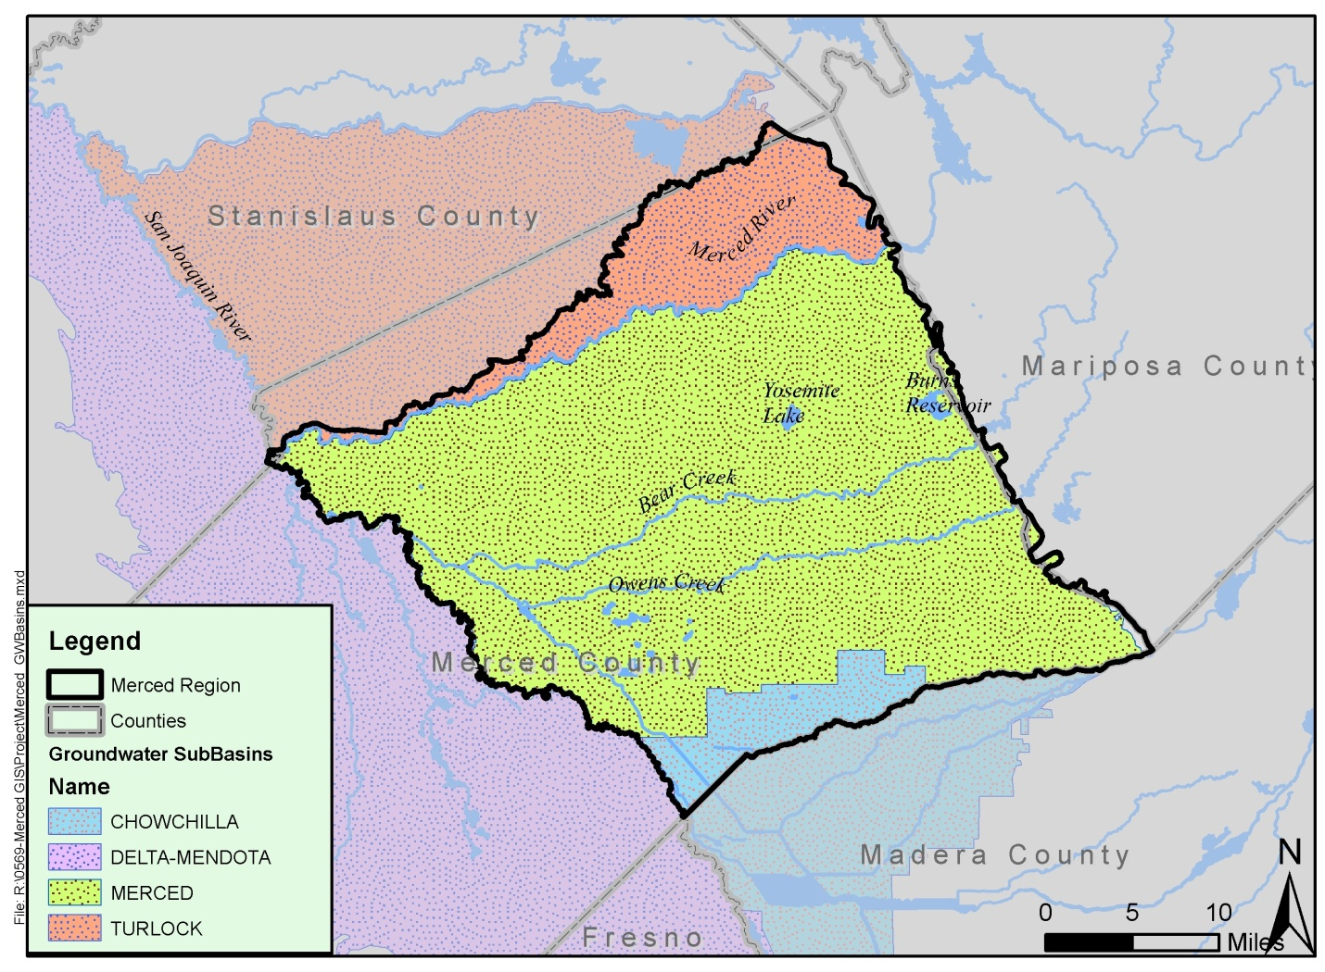
A large portion of the eastern half of Merced County (west of the San Joaquin River, 509,000 acres) is included in the Region, excluding the Ballico and Hilmar areas, which overlie the DWR-designated Turlock Subbasin (Basin 5-22.03 according to DWR Bulletin 118) north of the Merced River.
Land use patterns in the Merced Subbasin and the MIRWMP boundary area are dominated by agricultural uses including animal confinement (dairy and poultry), grazing, forage, row crop, nut and fruit trees relying heavily on purveyors/districts, private groundwater wells and surface water sources in some areas. Urban land use relies on groundwater in most instances. Land use is primarily controlled by local agencies (MAGPI 2009).
The MIRWMP region boundary is not based solely on geographic, hydrologic, and watershed delineations, considerations or characteristics. The boundary has been carefully evaluated and defined to align with water management issues, regional stakeholders, and water-related conflicts. The IRWM region was also designed to diversify and strengthen the regional water management portfolio. Specific considerations that contributed to the regional boundary definition included:
- Differing Hydrogeology. The crystalline basement rock at the eastern edge of the Merced Subbasin is a critical hydrogeologic feature that was considered in developing the MIRWMP regional boundary. With the exception of the Yosemite Valley Subbasin (Bulletin 118 Basin Number 5-69) in Yosemite National Park, no DWR-designated groundwater basins are located east of Merced County to the crest of the Sierra in the entire mountainous zones (Sierra Nevada range) of the San Joaquin River Hydrologic Region. In essence, counties such as Tuolumne, Mariposa and Madera (if utilizing their political/jurisdictional boundaries or well-defined watersheds) must manage the water systems in their mountainous areas in a dramatically different manner from the Merced Region, since the bulk of their water is in fluvial (creek and river) and fractured rock systems. In addition, the type of modeling needed to assess a water system in a mountainous watershed is entirely different from that required for watersheds dominated by a groundwater/alluvial basin setting.
- Distinct Land Use Patterns. Land use patterns in the mountainous areas to the east of the MIRWMP Region are dominated by national forest and timber, recreation, tourism, and rangeland grazing of forested areas and in the lower foothills. Significant portions of the land areas to the east of the MIRWMP boundary are controlled at the federal level as National Park Lands, National Forests, and Bureau of Land Management areas. The balance of land area in the mountainous areas to the east of the MIRWMP region is controlled by private entities and local agencies.
- Unique Water Management Needs and Challenges. West of the San Joaquin River and adjacent to the Merced Subbasin lies the Delta-Mendota Subbasin (5-22.07). The Delta-Mendota Subbasin is unique due to the composition of the contributing parent/alluvial materials and reliance on imported water sources as the Delta-Mendota Canal (DMC) and California Aqueduct (CAq) system. The Subbasins on the west side of the San Joaquin River from the San Joaquin Delta to Mendota Pool are areas have significantly different characteristics than the Merced Subbasin, including differences in hydrogeology, flooding from Cantua and Panoche drainages into the California Aqueduct, land use, water use patterns and water quality issues. There are localized areas of high iron, fluoride, nitrate, and boron in the Delta-Mendota Subbasin, selenium and salts are also of significant concern. As such, this area has different water management challenges and needs, and is appropriately covered by a different IRWM region.

Neighboring Regions
The Merced IRWM Region is located within the San Joaquin River Funding Area, which contains twelve IRWM Regions. Of these twelve regions, five IRWM planning regions share common boundaries with the Merced IRWM Region: the Madera Region, the Yosemite-Mariposa Region, the East Stanislaus Region, the Tuolumne-Stanislaus Region, and the Westside-San Joaquin Region (refer to Figure 2). Coordination between the Merced Region and these neighboring regions is described below. The Merced, Madera, Yosemite-Mariposa, and East Stanislaus regions were all approved by DWR in the 2011 RAP cycle. As such, coordination between these regions has been limited to-date, but is anticipated to increase as each region formalizes their governance structures and associated interregional coordination activities.
- Madera Region. TO BE UPDATED WITH INFORMATION ON COORDINATION TO-DATE
- Yosemite-Mariposa Region. TO BE UPDATED WITH INFORMATION ON COORDINATION TO-DATE
- East Stanislaus Region (ESR). Staff from the County of Merced and Merced Irrigation District routinely meet with members of the Turlock Groundwater Basin Association (TGBA); several TGBA members are founding members of the East Stanislaus Region.
- Tuolumne-Stanislaus Region. TO BE UPDATED WITH INFORMATION ON COORDINATION TO-DATE
- Westside-San Joaquin Region. TO BE UPDATED WITH INFORMATION ON COORDINATION TO-DATE

Figure 2: Merced IRWM Region and Neighboring IRWM Regions
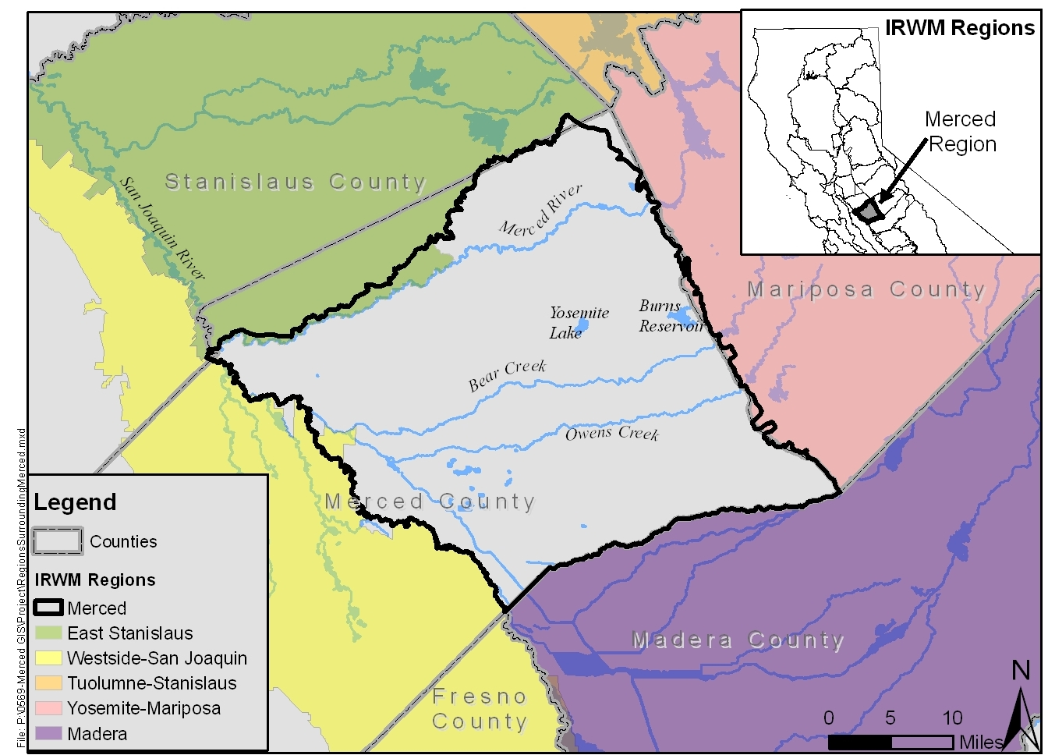

Watersheds and Water Systems

Watersheds
The San Joaquin Valley is a structural trough up to 200 miles long and 70 miles wide. It is filled with up to 32,000 feet of marine and continental sediments deposited during periodic inundation by the Pacific Ocean and by erosion of the surrounding mountains, respectively (MAGPI 2009).
The San Joaquin Valley has three groundwater basins designated and acknowledged by DWR and the Central Valley Regional Water Quality Control Board (CVRWQCB). Basin and Subbasin designations by DWR were first published in 1952 in Bulletin 118, and subsequently updated in 1975 and 1980. Updated Bulletin 118 data provides the primary source of hydrogeologic information for the Region (DWR 2004). The Central Valley Hydrologic Regions include the Sacramento River, San Joaquin River and Tulare Lake regions. The San Joaquin River Hydrologic Region contains ten (10) distinct Subbasins including the Merced Subbasin (Bulletin 118 Basin Number 5-22.04)
The Merced Subbasin includes lands south of the Merced River between the San Joaquin River on the west and the crystalline basement rock of the Sierra Nevada foothills on the east. The Subbasin boundary on the south stretches westerly along the Madera-Merced County line (Chowchilla River) and then between the boundary of the Le Grand-Athlone Water District and the Chowchilla Water District. The boundary continues west along the northern boundaries of Chowchilla Water District and El Nido Irrigation District. The southern boundary then follows the western boundary of El Nido Irrigation District south to the northern boundary of the Sierra Water District, which is followed westerly to the San Joaquin River (DWR 2004). An “Area of Interest” has also been designated to the north of the region boundary consisting of the Dry Creek watershed and low lying areas on the north side of the Merced River to its confluence with the San Joaquin River (MAGPI 2009). The Dry Creek watershed is a tributary to the Merced River.
There are three groundwater bodies in the Merced Subbasin and therefore in the MIRWMP Region: an unconfined water body, a confined water body, and a water body in consolidated rocks. The unconfined water body occurs in the unconsolidated deposits above and east of the Corcoran Clay, which underlies the western half of the sub basin at depths ranging between about 50 and 200 feet (DWR 1981), except in the western and southern parts of the area where clay lenses occur and semi-confined conditions exist. The confined water body occurs in the unconsolidated deposits below the Corcoran Clay and extends downward to the base of fresh water. The water body in consolidated rocks occurs under both unconfined and confined conditions. As of 1995, DWR estimated 15,700,000 acre-feet of groundwater to a depth of 300 feet is stored in this Subbasin (DWR 2004).
The Region lies within the San Joaquin Valley Floor Watershed, which is sub-divided into five hydrologic areas including El Nido-Stevinson, Fahr Creek, Merced, Montpelier, and Turlock, (refer to Figure 3 below). The Merced IRWM Region overlies each of these hydrologic areas, fully encompassing the El Nido-Stevinson, Fahr Creek, and Merced hydrologic areas.
Figure 3: Watersheds within the Merced IRWM Region
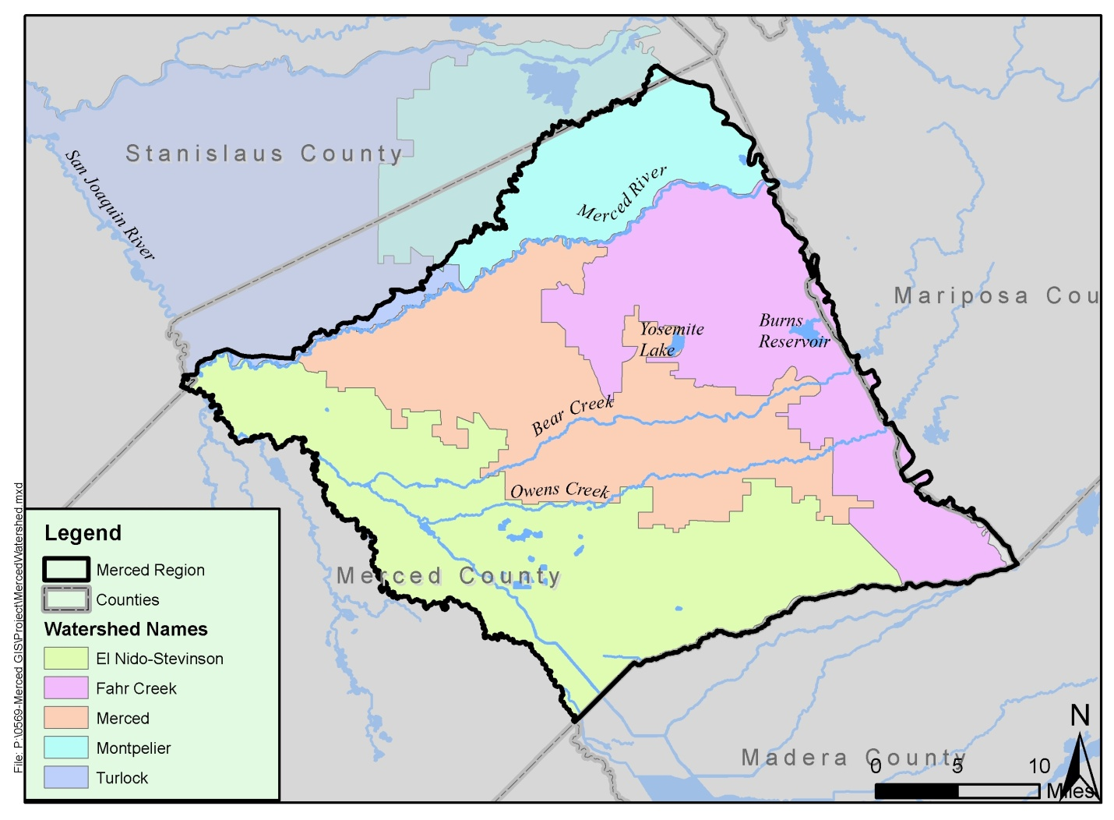

Water Systems and Distribution

Water Supply Systems
The Region contains a multitude of agencies and organizations that provide water supply and distribution. Domestic water systems within Merced County are generally small isolated systems providing water to individual communities (Merced County 2007). Most of the unincorporated areas outside of major communities are designated for agricultural use and receive their water supply from individual groundwater wells (Merced County 2007). However, many irrigation users are also served by small isolated systems similar to those for domestic uses. Agencies providing domestic and irrigation water services to the unincorporated areas of Merced County and within the Region (eastern Merced County) are shown in the following table.
Table 3: Agencies Providing Water Service to Unincorporated Areas of the MIRWMP Region
Agencies Providing Water Service to Unincorporated Areas in the MIRWMP Region
Public Water Supply Agencies
- Merquin County Water District  - Le Grand Community Services District  - Le Grand/Athlone Water District  - Chowchilla Water District  - Winton Water and Sanitary District | - Merced Irrigation District  - Stevinson Water District  - Turner Island Water District  - Planada Community Service District
Private Water Companies
- Meadowbrook Water Company | - Black Rascal Water Company  - Lone Tree Mutual Water Company

In addition to water systems within unincorporated areas of the Region, separate domestic systems are provided to the residents of the incorporated cities of Merced, Livingston, and Atwater. Services provided by the Region’s incorporated cities, in addition to other major water suppliers in the region are described in the following sections. Figure 4 provides an overview of the location of each of the water supply agencies and companies described below.
Figure 4: Water Supply Entities within the Region (SEE ATTACHED)

Merquin County Water District
The Merquin County Water District serves the unincorporated area of Stevinson, located within the westernmost portion of the region. Stevinson is a small community, containing approximately 82 parcels as of 2006 (Merced County 2007). ADDITIONAL DATA BEING COLLECTED
Le Grand Community Services District
The Le Grand Community Services District (LGCSD) provides domestic water service to residents in the unincorporated community of Le Grand located in the eastern portion of the Region. The community of Le Grand had a population of 1,659 in 2010, and is located in eastern Merced County approximately 12 miles southeast of the City of Merced. Municipal water is supplied to the community of Le Grand by three groundwater wells which are capable of producing 2 mgd. According to the 1990 Merced County General Plan, there is an average daily use of 0.96 mgd (Merced County 2007).
Le Grand – Athlone Water District
The Le Grand – Athlone Water District provides water service south of the community of Le Grand, up to the border of the Chowchilla Water District. The Le Grand – Athlone Water District distributes water purchased from the Merced Irrigation District (see information below). In 2002 the Le Grand – Athlone Water District served approximately 372 acre-feet of water from groundwater sources (MID 2003).
Chowchilla Water District
The Chowchilla Water District (CWD), formed in 1949, serves portions of both Merced County and Madera County, and therefore is partially located outside the Merced IRWM Region (CWD 2012). In total, CWD serves approximately 85,000 total acres of agricultural land, including over 400 water users.
CWD provides water from the Chowchilla River, Ash Slough, and Berenda Slough to convey irrigation waters from the Madera Canal and the Buchanan Dam. In total, CWD operates approximately 150 miles of unlined canals and 49 miles of pipeline within its distribution system.
CWD has rights to approximately 43,000 AFY of water from the Buchanan Dam, which is operated and maintained by the United States Army Corps of Engineers (USACOE). In addition, CWD has appropriative rights issued by the State Water Resources Control Board to divert water from the Chowchilla River. Lastly, CWD has contracted with the United States Bureau of Reclamation to receive water from the Madera Canal. Water supplied from the Madera Canal varies, with an average annual supply of approximately 90,187 acre-feet.
Winton Water and Sanitary District
The Winton Water and Sanitary District (WWSD) serves water to the unincorporated community of Winton and its surrounding area, which are located north of the City of Atwater. According to the 2010 United States Census, the population of the community of Winton was approximately 10,613 in 2010. WWSD provides water services to approximately 2,982 connections, supplying an annual average of approximately 1,748 AFY (Merced County Local Agency Formation Commission 2007).
Merced Irrigation District
The Merced Irrigation District (MID), formed in 1919, is a regional water supplier that supplies water to users within its service area. In addition, MID also delivers water to satisfy other entitlements, and provides water to irrigators located outside of the MID service area. Currently, MID sells water to the following agencies or water companies:
- Black Rascal Water District
- The City of Merced
- The City of Atwater
- The City of Livingston
- Meadowbrook Water Company
- Planada Community Services District
- Winton Water and Sanitation District
- Le Grand-Athlone Water District
In addition, MID has transfers and exchanges with the Stevinson Water District, Cowell Agreement Diverters, various riparian areas, the Merced National Wildlife Refuge, the Vernalis Adaptive Management Program, and the United States Bureau of Reclamation (MID 2003).
MID provides irrigation water to Eastern Merced County’s agricultural land. There are approximately 140,000 acres of farmland located within MID boundaries of which over 110,000 acres are irrigated. Approximately 320,000 acre-feet of water per year is distributed through 790 miles of canals and pipelines. MID possesses three “pre-1914” direct diversion rights from the Merced River. The Exchequer Mining Right permits the diversion of up to 6,000 cfs from the river when available as inflow. Direct Diversion Licenses #2685 and #6047 permit direct diversions from the Merced River up to a maximum of 1,500 cfs and 260 cfs, respectively. Under Storage License #11395, MID stores up to 516,000 acre-feet per year in Lake McClure (Merced County 2007).
The Merced Water Supply Plan provides a general plan for overall water system expansion and recommendations for managing the water supply for the study area. The Plan Update was prepared by the City of Merced and MID in conjunction with the University of California, Merced due to the occurrence of significant activities in the study area and a better understanding of water resources issues (Merced County 2007). The five goals identified in the Plan include:
- Manage groundwater resources;
- Provide a high-quality, reliable supply of water for cities;
- Protect and enhance the economic base;
- Protect MID’s Merced River water rights; and
- Maintain consensus on a water supply plan.
In the Plan Update, water needs and planning scenarios are addressed through the year 2040. The study area is composed of 582,000 acres located in Eastern Merced County that closely reflects the extent of the Merced Subbasin (Merced County 2007). Historical water data shows the use of surface water supplied by MID is decreasing while the pumping of groundwater for irrigation has been increasing. Several consequences can potentially occur if aquifer levels continue to decline including land subsidence, reduction of drought protection, imposition of regulatory control, higher energy usage and costs, and reduction in agricultural production.
Numerous planning scenarios were developed in the Plan Update by identifying potential future conditions and the actions necessary to address those conditions and reach program goals. Common solutions were identified among the planning scenarios and developed into a base level of solutions for immediate response.
The base level actions include intentional recharge site investigations, incentives and related system improvements, surface water conservation and automation, agricultural capacity improvements, urban water conservation, urban groundwater to surface water conversion, participation in water rights issues, and institutional program establishment. Other solutions are more costly and may not be required unless “triggers” occur. For example, future regulatory actions on the Merced River may trigger the need for drought relief wells. As a next step, the formation of a committee is suggested to identify beneficiaries of the program implementation and to allocate costs accordingly.
Stevinson Water District
Need to contact Bob Kelly for more information.

Turner Island Water District
The Turner Island Water District serves a small area in the southern portion of the Region, and is a member of the San Luis & Delta-Mendota Water Authority (SLDMWA 2011).
Planada Community Services District
The Planada Community Services District (Planada CSD) provides domestic water service to residents in the unincorporated community of Planada. The community of Planada had a year 2010 population of 4,584 and is located in eastern Merced County along State Route 140. Municipal water is supplied by five groundwater wells. Groundwater is chlorinated prior to conveyance through a pressurized system (Merced County 2007).
Black Rascal Water Company
Seeking additional information

Lone Tree Mutual Water Company
Seeking additional information

Meadowbrook Water Company
Need to contact Connie Farris for more information.

City of Merced
The City of Merced provides water supplies primarily to residential users, which included approximately 83,400 people in 2010. It is anticipated that the City’s population will continue to increase, reaching nearly 160,000 in 2030 (City of Merced 2011). In addition to residential users, the City of Merced also supplies water to commercial/institutional, industrial, and landscape irrigation users.
The City of Merced’s sole water supply source is groundwater, which is pumped from twenty-two active groundwater wells that are scattered throughout the City’s service area. Approximately four of the City’s groundwater wells are impacted by water quality issues associated with either arsenic, methyl-tertiary-butyl-ether (a gasoline additive), or nitrates. Although the City of Merced’s existing water supplies are provided solely from groundwater sources, by 2015 the City anticipates using a small amount of surface water from MID to supplement its water supply (City of Merced 2011).
The City of Merced is also responsible for collecting, treating, and disposing of wastewater in the City’s growth area, also known as the Specific Urban Development Plan or SUDP. While the City recently completed upgrades to its wastewater treatment facility to increase treatment capacity to tertiary levels in accordance with Title 22 of the California Code of Regulations, the City does not currently plan to supply recycled water within its service area (City of Merced 2011).
City of Atwater
The City of Atwater provides domestic water service to a growing amount of people. According to the 2010 United States Census, the population of Atwater grew by almost 22% from 2000 to 2010, with the population reaching 28,168 in 2010. The City of Atwater operates a municipal water system that utilizes local groundwater wells to provide water to the city’s residents. The City of Atwater does not treat groundwater prior to delivering it to customers, with the exception of chlorine injection as required by the State of California (City of Atwater 2006). The City’s municipal water system consists of 11 wells, 9 of which are active, and 2 of which are on standby due to elevated concentrations of dibromochloropropane (DBCP), a pesticide. In 2005, the City of Atwater pumped approximately 9,606 acre-feet of water, which constituted the entire water supply for the city, and was supplied from the Merced Subbasin (City of Atwater 2006).
City of Livingston
The City of Livingston provides water supplies to its growing population, which was approximately 13,058 in 2010. The sole source of water supply for the City of Livingston is groundwater, which is pumped from eight active groundwater wells that have a combined capacity of 1.0 million gallons (City of Livingston 2007). The City’s groundwater is generally of high quality, although high levels of the pesticide DBCP and nitrates have been detected in isolated locations (City of Livingston 2007).

Wastewater
Most of the sanitary sewer systems within the unincorporated areas of the Region serve individual small communities. Sanitary sewer service within the unincorporated County portions of the Region is generally provided by special districts including community service districts, public utility districts, sanitary districts, and sewer maintenance districts (Merced County 2007). Some agencies provide sewer collection service only, and contract with surrounding agencies for wastewater treatment and disposal. Some of the unincorporated communities of Merced County lack sanitary sewer infrastructure, and are serviced by individual or community septic systems (Merced County 2007). Communities within the Region currently lacking sanitary sewer infrastructure are listed below.
- Celeste
- Cressy
- El Nido
- Stevinson
- Tuttle
Most of the unincorporated areas outside of major communities are designated for agricultural use and discharge their wastewater through onsite wastewater treatment systems. For areas serviced by individual or community systems, property owners are generally responsible for maintenance and improvements (Merced County 2007).
The County’s 1990 General Plan does not discuss sanitary sewer service, and defers wastewater transmission, treatment, and disposal planning to local service providers. Thus, there is little coordination between the service capacities and capabilities of local wastewater service providers and increasing demands for service as a result of land use decisions of private project proponents and Merced County (Merced County 2007).
The paragraphs to follow describe the current state of sewer infrastructure in the unincorporated communities of Merced County and the incorporated cities of Merced, Atwater, and Livingston. Figure 5 provides an overview of the location of each of the wastewater agencies and companies described below.
Figure 5: Wastewater Entities within the Region (TO BE DEVELOPED)

Franklin County Water District
The Franklin County Water District (FCWD) provides sanitary sewer collection and treatment services to residents in the unincorporated community of Franklin-Beachwood. The FCWD owns and operates a wastewater treatment facility (WWTF) located on the eastern side of the community. The community WWTF consists of headworks with a bar screen, an aerated pond with two aerators, followed by eight evaporation/percolation ponds totaling 30 acres. The WWTF is operated in accordance with Waste Discharge Requirements Order No. 89-171 (RWQCB). Upon adoption, the Order limited the 30-day average daily flow to 0.4 mgd until collection system improvements could be implemented, due to the influent sewer line and pump station capacity limitations. Upon completion of the improvements, the Order limits the 30-day average daily flow to 0.6 mgd. A Notice of Violation dated February 2002 from the RWQCB (related to disposal of wastes and failure to complete self-monitoring reports) indicated wastewater flows had increased to an average of 0.43 mgd at the time of the inspection. The Order states that the evaporation/percolation ponds have a capacity to treat 0.6 mgd while the aeration ponds are designed to treat flows up to 0.8 mgd (Merced County 2007).
Le Grand Community Services District
In addition to domestic water service, the Le Grand Community Services District (LGCSD) also provides sanitary sewer collection and treatment services to the community of Le Grand. The LGCSD owns and operates a WWTF located southwest of the community of Le Grand (Merced County 2007).
The expanded WWTF is operated in accordance with Waste Discharge Requirements Order No. 97-053 (RWQCB). The WWTF consists of headworks with a mechanically cleaned bar screen and screenings press, two partially mixed aerated lagoons with surface aerators, and one stabilization pond. Disposal is to two evaporation/percolation ponds and a 37-acre reuse area of fiber, fodder, and seed crops. Sludge removed from the ponds is also applied to the reuse area. According to the Order adopted by the RWQCB the capacity of the WWTF is 0.35 mgd. The stabilization pond was designed in a manner that will allow a future increase in capacity to 0.50 mgd. A Notice of Violation dated December 2001 from the RWQCB (related to self-monitoring report requirements) indicated wastewater flows to be 0.15 mgd at the time of the inspection (Merced County 2007).
Planada Community Services District
In addition to domestic water service, the Planada Community Services District (Planada CSD) also provides sanitary sewer collection and treatment services to the community of Planada. The Planada CSD owns and operates a WWTF located to the southwest of the community (Merced County 2007).
The WWTF is operated in accordance with Waste Discharge Requirements Order (WDR Order) No. R5-5005-0009 (RWQCB). The treatment system consists of: a metering manhole; an influent pump station; a grinder to shred solids in raw sewage; an influent distribution box; three aerated lagoons; three stabilization ponds; six intermittent sand filters; six pressure filter pods; a chlorination manhole; a chlorine contact pipe; and an effluent pump station. Treated effluent is discharged to Miles Creek, a tributary to the San Joaquin River (Merced County 2007).
According to the WDR Order, the average daily flow rate is 0.36 mgd and the maximum daily flow rate is 1.07 mgd (based on 2000/2001 data). The design monthly daily average flow rate for the WWTF is 0.53 mgd (Merced County 2007).
Winton Water and Sanitary District
A treatment facility feasibility study was proposed for the Castle Airport/Winton Area by Merced County in 2007. The feasibility study was prompted by an implementation plan proposed by the Merced County Department of Commerce Aviation and Economic Development. The implementation plan is designed to fully utilize the resources of the former Castle Air Force Base (now designated as the Castle Airport). The recommended alternative in the feasibility study is a 3.0 mgd tertiary treatment plant to serve the 1600 acre Castle Airport and approximately 800 acres within the unincorporated area of the Winton Water and Sanitary District (WWSD). The treatment facility would discharge treated effluent into the Casad Lateral Canal in the summer with effluent applied to on-site percolation ponds in the winter. Currently the WWSD discharges raw wastewater to the City of Atwater for treatment and disposal (Merced County 2007).
City of Merced
In addition to providing water supply within its service area, the City of Merced is also responsible for collecting, treating, and disposing of wastewater. Currently, all treated effluent from the City of Merced wastewater treatment facility is discharged through a gravity channel to Hartley Slough, to a Food Processing and Land Application Area (FPLAA) owned by the City, and to a wildlife management area wetland. Treated effluent that is conveyed to the Hartley Slough and the FPLAA is used for agricultural irrigation purposes, while the water that is conveyed to the wildlife management area wetland is used to create a series of percolation and evaporation ponds. According to estimates from the City’s 2010 Urban Water Management Plan, in 2010 approximately half of the City’s wastewater was treated to secondary levels and conveyed to the wildlife management area wetland (City of Merced 2011).
The City of Merced recently completed a significant upgrade and expansion design project to the City’s wastewater treatment plant (WWTP) to produce disinfected tertiary effluent in accordance with Title 22 of the California Code of Regulations. With the new upgrade, wastewater generated within the City is conveyed to the City’s WWTP. The wastewater is screened, rocks and sand removed; and water is then pumped to the primary clarifiers that allow any particles in the water to settle. The water flows to aeration basins where bacteria consume organic material and secondary clarifiers are then used to settle out the bacteria. Secondary effluent is chemically conditioned, filtered, and disinfected with ultraviolet light. The treated water is then aerated prior to discharge into Hartley Slough. After final treatment, the water will also be suitable for unrestricted reuse for agriculture purposes. The waste solids, or sludge, is digested and dried so the material can be applied as a soil amendment.
The City will continue to provide treated effluent to the Hartley Slough, FPLAA, and wildlife management area wetland, and does not have current plans to distribute recycled water. The quantity of treated effluent conveyed to these three areas is anticipated to increase substantially compared to current levels. Currently the City disposes of approximately 2,284 AFY of treated effluent, and anticipates disposing of over 17,000 AFY by 2030 (City of Merced 2011).
City of Atwater
The City of Atwater also provides wastewater collection and treatment services within its service area, and in 2005, all of the city’s wastewater flows were beneficially reused and recycled through land disposal. Land disposal includes application at a local farm for irrigation purposes and use by the United States Fish and Wildlife Service (USFWS) for wetland habitat (City of Atwater 2006).
The City of Atwater collects and treats approximately 4.2 million gallons of wastewater per day, or approximately 4,705 AFY. Wastewater is collected through a network of sanitary sewer collection pipelines, and gravity fed to the City’s wastewater treatment plant via 18 sewer pump stations. After treatment at the City’s wastewater treatment plant, treated effluent is conveyed from the Atwater Drain to land disposal methods explained above. In addition, solids generated at the wastewater treatment plant are dried and applied to the City’s sludge reuse facility or one of several permitted sites in Merced County that are used to grow hay (City of Atwater 2006).
The City is in the process of upgrading its existing wastewater treatment plant while plans to build a new plant are under development. The upgrade will increase average flow capacity to 6 mgd (expandable to 12 mgd ultimate) and comply with new regulatory requirements for advanced treatment. The upgrade includes the following major treatment unit-processes:
- Headworks including screening, grit removal and odor control provisions.
- Two biological nutrient removal oxidation ditches with secondary clarifiers providing for effluent ammonia below 2 mg/L and nitrates below 10. Effluent BOD and SS will be consistently below 10 mg/L. Provisions for supplementary alkalinity addition, which might be required to fuel the nitrification process, are also provided.
- Effluent filtration/UV disinfection facilities.
- Sludge digestion/dewatering facilities including cake storage with off-haul provisions.
City of Livingston
The City of Livingston provides sanitary sewer service within its service area, including a collection system of mains, manholes, service laterals, pump stations, and trunk sewer mains that are used to convey wastewater to the City’s domestic wastewater treatment plant. Treated effluent from the City’s domestic wastewater treatment plant is sent to percolation ponds and lined sludge drying beds, and as of 2008 was not reclaimed. In addition to the City’s domestic wastewater treatment plant, the City also operates an industrial wastewater treatment plant that is used to treat flows from a private poultry processing plant. The industrial wastewater treatment plant consists of two aerated treatment ponds and ten treatment and percolation ponds with a total surface area of approximately 83 acres (City of Atwater 2007).

Recycled Water
As discussed previously, sanitary sewer service (wastewater treatment) within the Region is generally provided by special districts within the unincorporated areas of Merced County, and by the cities of Merced, Atwater, and Livingston.
There are currently no supplies of recycled water for domestic uses within the Region. However, the Cities of Merced and Atwater both currently reuse treated wastewater effluent for beneficial uses. The City of Merced recently upgraded its wastewater treatment plant to treat wastewater to disinfected tertiary levels in accordance with Title 22 of the California Code of Regulations. As such, wastewater from the City of Merced could potentially be used for industrial and irrigation uses in accordance with Title 22. According to the City of Merced 2010 Urban Water Management Plan, there are no plans to increase recycled water use within the city at this time (City of Merced 2011). Wastewater treated by the City of Atwater does not adhere to standards established by Title 22 of the California Code of Regulations, and therefore cannot be used for expanded recycled water uses (City of Atwater 2006).

Water Conservation
In response to declining groundwater levels in the Merced Subbasin, water supply entities within the Region are working to implement programs to maintain groundwater levels, including conservation programs. Conservation programs that are being implemented in the Region are described below.
Merced Irrigation District
In 2003 MID completed a Water Management Plan in accordance with Assembly Bill 3616 (AB 3616), also known as the Agricultural Water Suppliers Efficient Water Management Practices Act. The plan focuses on establishment of applicable Efficient Water Management Practices (EWMPs), which include water conservation efforts (MID 2003). EWMPs within MID’s existing Water Management Plan that pertain to conservation include:
- Designate a Water Conservation Coordinator (complete since 1998);
- Program to support the availability of water management services to users, including:
  - Support a full-time staff Water Conservation Specialist; and
  - Provide monthly billing report of water usage to customers.
- Evaluate and improve efficiencies of water suppliers’ pumps;
- Line or pipe ditches and canals;
- Optimize conjunctive use; and
- Pricing and incentives.
According to the Merced Groundwater Basin Management Plan (MAGPI 2008), in total MID has implemented various recharge and conservation efforts that have resulted in the cumulative in-lieu recharge of approximately 300,000 acre-feet of water since 2001.
City of Merced
In accordance with provisions established under Senate Bill x7-7 (SBx7-7), the Water Conservation Act of 2009, the City of Merced established water reduction targets to reduce urban water consumption by 20% by the year 2020 (City of Merced 2011). According to the City’s 2010 Urban Water Management Plan, the City will implement the following demand management measures to assist in achieving compliance with requirements set forth by SBx7-7:
- Residential Plumbing Retrofit – installing physical devices to reduce the amount of water used or to limit the amount of water that can be served to a customer;
- Water System Audits – the process of accounting for water use throughout a water system in order to quantify the unaccounted-for water.
- Metering with Commodity Rates – installing meters for all new connections to allow billing by volume of use.
- Public Information Program – distributing information to the public through a variety of methods including brochures, press releases, school curricula, educational flyers, commercials, etc.
- School Education Program – implementing a school education program that includes providing educational materials and instructional assistance.
- Water Conservation Coordinator – employing a Water Conservation Specialist who serves as the City’s Conservation Coordinator.
- Water Waste Prohibition – implementing ordinances to prohibit the waste of water.

Agricultural Water
Agriculture is the dominant land use in Merced County, estimated to account for more than 90 percent of all land as of 2007 (Merced County 2007). Based on the Merced Groundwater Basin Management Plan, the majority of water used within the Merced Subbasin has historically been and continues to be used for agricultural purposes (MAGPI 2008).
Despite the predominant use of groundwater, agricultural water within the Region is sourced from both surface water and groundwater, with the Merced River functioning as the primary surface water source. Within the boundaries of MID’s service area, agricultural demands ranged from 218,000 AFY to 313,000 AFY, with an average of 275,000 AFY from 1994 to 2007 (MAGPI 2008).

Stormwater and Flood Management
The Merced Region has a long history of active stormwater and flood management, dating back to development of the original Merced County Stream Group project under authorization of the Flood Control Act of 1944 as part of the comprehensive plan for flood control for the Sacramento and San Joaquin River Basins. In recent years, the Merced Streams Group project has been modified in response to current conditions and feasibility assessments. Currently, the Merced Streams Group project is under General Re-evaluation by the Army Corps of Engineers (MAGPI 2009).
The Merced Streams Group project focuses on the Merced County Stream Group, which is a collection of streams within the County, including: Black Rascal Creek, Canal Creek, Bear Creek, Burns Creek, Edendale Creek, Fahrens Creek, Miles Creek, Owens Creek, and Mariposa Creek. The creeks comprising the Merced County Stream Group meander through the City of Merced as well as the unincorporated areas of Le Grand, Planada, and the Franklin/Beachwood area, in which flooding is a recurring concern (MAGPI 2009).
Figure 6 presents an overview of areas with potential flood concerns according to mapping from the Federal Emergency Management Agency (FEMA), which are described below. In general, flood hazard zones are those subject to inundation by a one percent annual chance flood event (100 year flood) or a 0.2 percent annual chance flood event (500 year flood) (FEMA 2010). As indicated within Figure 6, several areas within the Region are classified within the FEMA-designated 100-year or 500-year flood zones, and these areas are directly related to creeks within the Merced County Stream Group such as Owens Creek and Bear Creek.
- Flood Zone A: Areas subject to inundation by the 1-percent-annual-chance flood event (100 year flood zone) but not determined by detailed methods. Mandatory flood insurance purchase requirements and floodplain management standards apply.
- Flood Zone AE: Areas subject to inundation by the 1-percent-annual-chance flood event (100 year flood zone) determined by detailed methods. Mandatory flood insurance purchase requirements and floodplain management standards apply.
- Flood Zone AH: Areas subject to inundation by 1-percent-annual-chance (100 year flood zone) from shallow flooding (usually areas of ponding) where average depths are between one and three feet (not determined by detailed methods). Mandatory flood insurance purchase requirements and floodplain management standards apply.
- Flood Zone AO: Areas subject to inundation by 1-percent-annual-chance (100 year flood) from shallow flooding (usually sheet flow on sloping terrain) where average depths are between one and three feet (determined by detailed methods). Mandatory flood insurance purchase requirements and floodplain management standards apply.
- Flood Zone D: Areas with possible but undetermined flood hazards.
- Flood Zone X: Areas of minimal flood hazard.
- 0.2 Percent Annual Chance Flood Hazard: Areas subject to inundation by 0.2-percent annual chance (500 year flood).
Figure 6: FEMA Designated Flood Zones within the Region
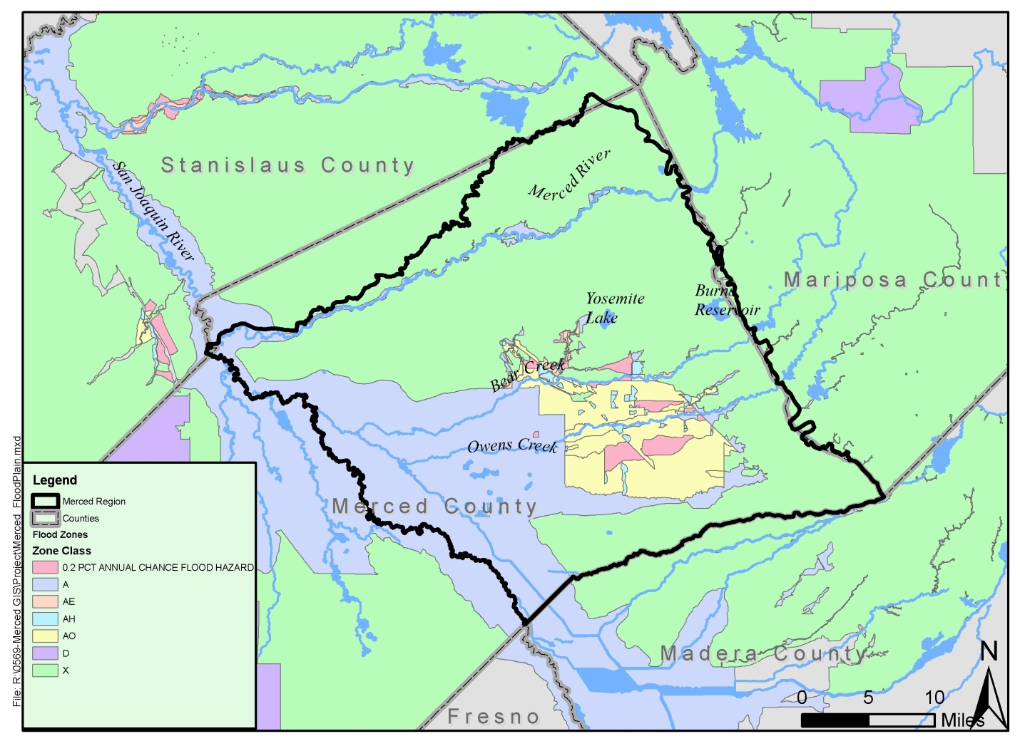
The County of Merced is the lead agency providing storm drain infrastructure within the unincorporated areas of the Region (Merced County 2007). In addition to the County, various subdivisions within the Merced Irrigation District service area use MID canals to discharge stormwater. In general, developers are required to provide storm drainage systems on-site at developments within the unincorporated County. Furthermore, storm drain infrastructure falls under the individual jurisdictions of the cities of Atwater, Livingston, and Merced (Merced County 2007).
In 2007 the cities of Atwater and Merced, the County of Merced, and MID, collectively referred to as the Merced Storm Water Group (MSWG) completed a comprehensive Storm Water Management Program (SWMP). The purpose of the SWMP was to implement, to the Maximum Extent Practicable (MEP), the discharge of pollutants from the MSWG agencies. The SWMP identifies structural and non-structural best management practices (BMPs) that can be implemented to treat and reduce stormwater pollution (Merced Storm Water Group 2007).

Natural Communities and Habitats
The Region contains a vast amount of open space and agricultural lands, which provide unique natural communities and habitats such as pristine vernal pool grasslands, highly specialized unique plant and animal species, large managed wetland preserves, and wildlife-based recreational opportunities (Merced County 2007).
The East Merced Resource Conservation District (EMRCD) works to develop and further ongoing programs to conserve natural resources in eastern Merced County (east of the San Joaquin River). EMRCD has identified three primary geographic land use regions within their jurisdiction, which almost covers the entirety of the Region (EMRCD N.D.). These geographic land uses, which are considered important to the overall health and functioning of the watersheds within the Region include: crop and dairy lands, rangelands and vernal pools, and the Lower Merced River Corridor. Figure 7 provides an overview of land uses within the Region, including habitat areas.
The Cities of Merced and Atwater both have conjunctive reuse programs that provide water treated from local wastewater facilities for use on crop and dairy lands and designated wetland areas. Environmental water demands are growing within the Region, and approximately 15,000 AFY are used at the Merced National Wildlife Refuge to sustain local habitats (MAGPI 2008). Since 2000, MID has released approximately 60,000 AFY of water from the Merced River for the Vernalis Adaptive Management Plan to facilitate the migration of juvenile Chinook salmon. In addition, MID periodically releases water (approximately 25,000 AFY) from the Merced River to the Environmental Water Account for protection and restoration of at-risk fish species listed under the Federal Endangered Species Act (ESA) and the California ESA (MAGPI 2008).
Figure 7: Regional Habitat Map
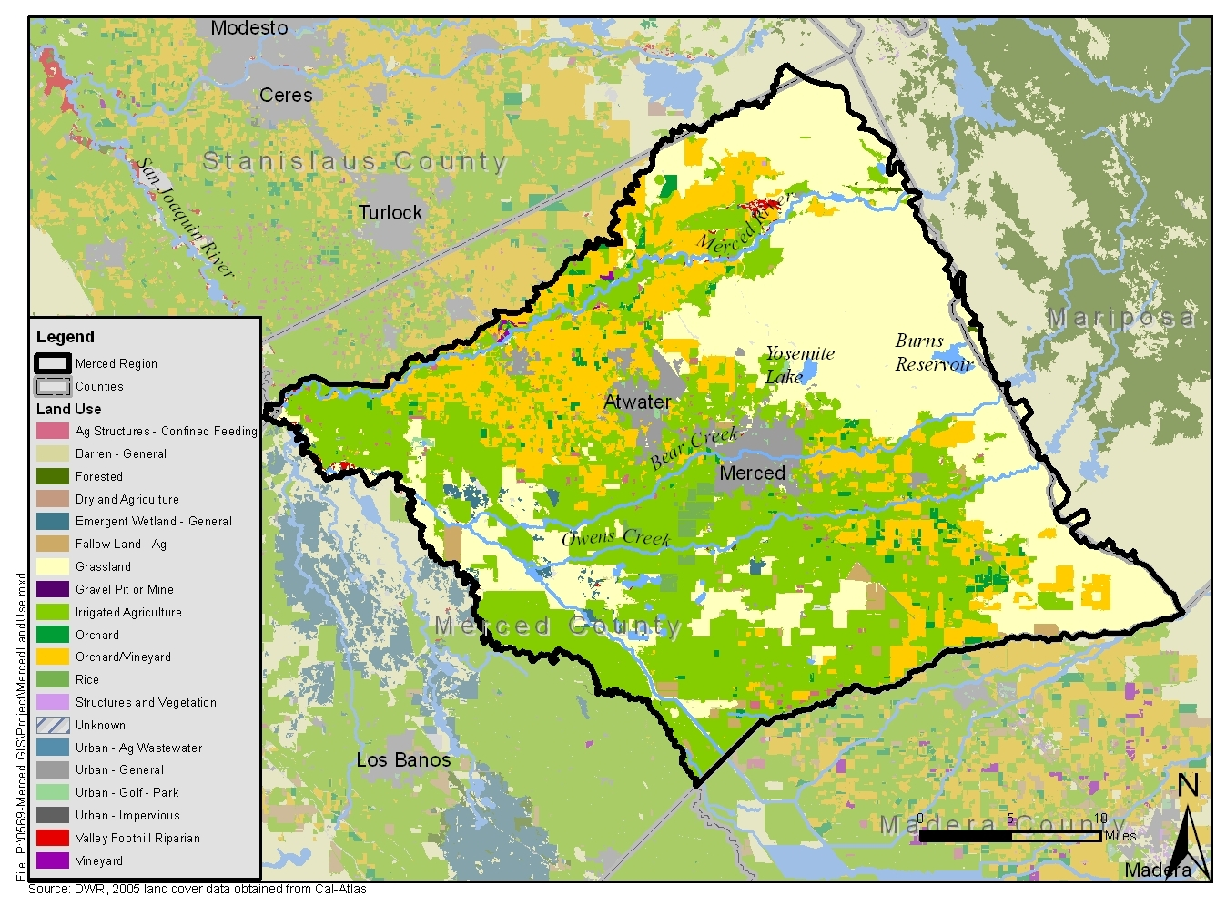

Internal Boundaries

Land Use Agencies
There are four agencies within the Region with land use jurisdiction: the County of Merced, the City of Merced, the City of Livingston, and the City of Atwater. The cities of Merced, Atwater, and Livingston reside solely within the Region, while only the eastern portion of Merced County lies within the Region. The Region encompasses the following unincorporated communities within eastern Merced County: Celeste, Cressey, El Nido, Franklin/Beachwood, Le Grand, Planada, Snelling, Stevinson, Tuttle, and Winton. Figure 8 demonstrates the location of the incorporated cities and unincorporated communities within the Region.
Figure 8: Land Use Agencies

Water Supplies and Demand

Water Supply
Water supply within the Region is primarily sourced from the Merced Subbasin. In addition to groundwater sources, the Region also has surface water sources from the Merced River and to a lesser extent from smaller creeks and streams.

Merced Subbasin
Groundwater Supply Management
Management of water supplies within the Merced Subbasin is complex, involving a multitude of agencies and interested parties. The Merced Irrigation District and the City of Merced prepared a final draft Groundwater Management Plan (GWMP) in 1997 to comply with requirements of the Groundwater Management Act (also known as Assembly Bill 3030 or AB3030). Due to broad interest in groundwater management within the Region, in December 1997 water purveyors within the Merced Subbasin signed a Memorandum of Understanding (MOU) to create the Merced Area Groundwater Pool Interests (MAGPI), formally agreeing to work cooperatively to promote conjunctive use projects within the Merced Subbasin (MAGPI 2008). MAGPI has a Board of Directors of fifteen agencies and one non-purveyor member at large (EMRCD) that hold open public meetings associated with groundwater management in accordance with provisions of AB3030. The MAGPI Board of Directors is comprised of the following agencies:

- Merced County
- City of Merced
- City of Atwater
- City of Livingston
- Winton Water and Sanitary District
- Meadowbrook Water Company
- Planada Community Service District
- Le Grand Community Service District
- Black Rascal Water Company
- Merced Irrigation District
- Stevinson Water District
- Le Grand-Athlone Water District
- Turner Island Water District
- Merquin County Water District
- Lone Tree Mutual Water Company
- East Merced Resource Conservation District

In 2008, MAGPI adopted a Groundwater Management Plan Update (2008 GWMP Update), which supersedes the 1997 GWMP produced by MID and the City of Merced (MAGPI 2008).
Groundwater Levels and Historical Trends
According to the 2008 GWMP Update, Merced Subbasin groundwater elevations have been monitored by DWR, MID, and other entities since the 1950’s. This monitoring data demonstrates that since 1980 average groundwater levels beneath the Merced Subbasin have declined approximately 14 feet, with most of this decline occurring between 1980 and 1996 (MAGPI 2008). As such, the Merced Subbasin is considered to be in a state of mild long-term groundwater level decline. However, there is one exception to this trend in the El Nido area, where groundwater levels have shown a substantial increase since 1980 due to increased delivery of surface water to the area by MID (MAGPI 2008).
Existing and Projected Groundwater Supplies
From 1995 to 2007, groundwater levels within the Merced Subbasin had an average groundwater decline of approximately 3.7 feet. Using an assumption of a 9.0 percent average specific yield, this decline in groundwater levels represents a decrease in storage capacity of approximately 117,200 acre-feet (MAGPI 2008). Data for the Region demonstrates that the Merced Subbasin experiences periods of long-term groundwater level decline and subsequent recovery, with a general trend toward mild groundwater level decline and a cumulative decrease in storage of approximately 720,000 acre-feet from 1980 to 2007 (MAGPI 2002). According to the MID Water Management Plan, the safe yield from the Merced Subbasin is 540,000 AFY, which constitutes the projected maximum supply available (MID 2003).
TO BE UPDATED WITH ACTUAL SUPPLY PROJECTIONS FOR AT LEAST 20 YEARS.

Surface Water
Surface water is primarily supplied to the Region via the Merced River. Water supplies from the Merced River originate from diversions into the MID distribution system through the Northside Canal from the Merced Falls Dam, and through the Main Canal from the Crocker-Huffman Diversion Dam. From 1994 to 2007 MID diversions from the Merced River ranged from 430,600 AFY to 571,400 AFY, with an average of approximately 499,400 AFY (MAGPI 2008). The amount of surface water available for use within the Region varies depending upon the amount of water present.
Other surface water sources include permanent and ephemeral streams such as Bear Creek, Black Rascal Creek, Burns Creek, Canal Creek, Cottonwood Creek, Deadman Creek, Fahrens Creek, Little Dutchman Creek, Mariposa Creek, and Owens Creek. Gauging stations located on Burns Creek, Bear Creek, Mariposa Creek, and Owens Creek indicate that since 1993, annual outflow from the Region’s creeks has ranged from 15,000 AFY to 238,700 AFY, with an average of approximately 94,000 AFY (MAGPI 2008). DWR estimates that approximately half of the inflow from surface water bodies (approximately 47,000 AFY) infiltrates and recharges the Merced Subbasin (MAGPI 2008).
TO BE UPDATED WITH ACTUAL SUPPLY PROJECTIONS FOR AT LEAST 20 YEARS.

Water Demand

Groundwater
The Merced Subbasin is not adjudicated. Therefore, there are no defined legal pumping rights or constraints on groundwater pumping for groundwater users in the Region. In addition, groundwater demands (groundwater use) are difficult to record within the Region, because there are numerous un-metered private groundwater wells (City of Merced 2011). Groundwater modeling efforts have estimated that groundwater pumping within the Region peaked in 1974 at a total demand of 630,000 AFY (MAGPI 2002). Further, these modeling efforts indicate that groundwater demands are highest during dry years, likely due to the fact that groundwater is primarily used for agricultural purposes (irrigation) (MAGPI 2002). Conversely, modeling data indicates that during wet years when surface water is abundant, groundwater pumping is significantly decreased (MAGPI 2002). This modeling data reinforces the trend noted previously, in which groundwater levels stabilize or recover to a higher elevation during multiple yet years.

Water Quality
Water quality objectives for the Region are established within the Water Quality Control Plan for the San Joaquin River Basin (Basin Plan). The Basin Plan is intended to protect surface and groundwater quality throughout the San Joaquin River Basin, which includes the Merced Region. Maximum containment levels (MCLs), established by the U.S. Environmental Protection Agency (USEPA) under the Safe Drinking Water Act, are the standard by which water quality is described throughout this section. MCLs are the maximum allowable concentration of contaminants in surface or groundwater to be used for drinking water supply (USEPA 2012).

Groundwater Quality
Groundwater within the Merced Subbasin contains both man-made and naturally occurring constituents. Some of these constituents either currently have or have the potential to impact groundwater use within the Region in the future. Those water quality constituents and their potential impacts on groundwater quality within the Region are described below (MAGPI 2002 and MAGPI 2008).
Salinity
Salinity, which is generally measured by total dissolved solids (TDS), has an MCL of 1,000 (upper limit) to 1,500 (short-term limit) parts per million (ppm). TDS in the eastern two-thirds of the Merced Subbasin generally measures less than 500 ppm. Salinity increases in a westward direction toward the San Joaquin River and southward toward the Chowchilla River. In these areas, high TDS water is found in wells deeper than 350 feet, although shallow wells generally contain TDS levels below 1,000 ppm.
In general, groundwater with high concentrations of TDS is present beneath the entire Merced Subbasin, generally located at depths between 400 to 800 feet. Saline waters originating from ancient marine sediments are migrating upward and mixing with freshwater in the basin. This process is a result of natural pressure; however, pumping of deep wells within the western and southern parts of the Merced Subbasin may be causing these saline waters to upwell and mix with fresh water more rapidly than under natural conditions.
Nitrates
Nitrates originate from both natural and man-made sources, and can be found in groundwater in many parts of the San Joaquin Valley. Nitrates are generally of concern for potable water supplies, and are not a concern for many crops because they act as a fertilizer. However, crops such as grape vineyards may be adversely impacted by high nitrate concentrations.
The MCL for nitrate is 45 ppm for public drinking water supplies, and several municipal water districts have reported wells that have reached or are approaching the MCL. High nitrate concentrations, which are generally found in shallower groundwater zones, have been attributed to sources such as agricultural fertilizers, sewer effluent, effluent from onsite wastewater treatment systems, and animal wastes.
Iron and Manganese
Iron and manganese are both regulated through secondary MCLs, which are non-enforceable guidelines that regulate contaminants that may cause cosmetic or aesthetic effects in drinking water. The secondary MCLs for iron and manganese are 0.3 milligrams per liter (mg/L) and 0.05 mg/L, respectively.
Groundwater in some portions of the Merced Subbasin contains elevated iron and manganese concentrations that exceed the secondary MCLs. Such areas are generally at shallow depths where oxygen levels are low or associated with shallow groundwater areas near streams.
Arsenic
Arsenic, which can have human health impacts, is naturally found within many bedrock formations. The current California MCL for arsenic is 0.010 mg/L. As of 2008, arsenic concentrations in water from many public supply wells within the Merced Subbasin were below 0.010 mg/L; however, if the MCL for this constituent is lowered, it may have adverse impacts on groundwater usage and treatment costs within the Region.
Radionuclides
Radionuclides, including alpha particles and uranium, have MCLs of 15 picocuries per liter and 30 micrograms per liter (µg/L), respectively. Data for radionuclides in the Region is not available at this time, and testing for these constituents is generally limited to public water systems.
Bacteria
Levels of bacteria within the Merced Subbasin are generally acceptable in deep groundwater aquifers. Bacteria is of primary concern for drinking water systems, and bacteria is regulated based on the number of service connections within a given drinking water system. The California Department of Public Health requires testing for pathogens (disease-causing organisms) within drinking water systems. Elevated bacteria in groundwater can occur due to inadequate construction, improperly located, destroyed, and abandoned groundwater wells, and improper use of groundwater wells for waste disposal.
Petroleum Hydrocarbons
Petroleum hydrocarbons, including oxygenates such as methyl-tertiary-butyl-ether (MTBE), have been released from underground storage tanks (USTs). Most of these cases are localized in nature, and spills associated with USTs are regulated by the State Water Resources Control Board and the Merced County Division of Environmental Health (MCDEH). MCDEH has a contract with the State Water Resources Control Board to provide mitigation services to define and clean up releases resulting from leaking USTs.
MTBE is thought to impact isolated wells within the Region; for example, the City of Merced has reported operational changes to address MTBE contamination within local groundwater wells.
Pesticides
Dibromochloropropane (DBCP), a pesticide banned in 1977, continues to be a source of pesticide contamination within the Region. The MCL for DBCP is 0.0002 mg/L (0.2 µg/L), as DBCP can potentially be a carcinogen even at very low concentrations. DBCP has been found in public water supply and domestic wells.
In addition, the cleaning and degreasing solvent, 1,2,3-trichloropropane (1,2,3-TCP), also used as a soil fumigant, has been detected in shallow groundwater in the Livingston area. The MCL for 1,2,3,-TCP is 0.005 µg/L.
Finally, ethylene dibromide (EDB), a related nemacide banned in the 1980’s, has been detected in at least one public water supply well and several domestic wells in the Atwater/Livingston area.
Trichloroethylene
Trichloroethylene (TCE) is a volatile organic compound (VOC), used as a solvent for dyes, rug cleaners, and as a degreaser for metal parts. The MCL for TCE is 0.005 mg/L due to carcinogenicity.
TCE has been detected at levels exceeding the MCL in two locations in the Merced Subbasin. These areas, the Castle Airport Aviation and Development Center and the City of Merced’s Eastern Industrial Park, are both undergoing remediation activities.
Perchloroethylene
Perchloroethyene (PCE), which is also a VOC, has been detected in isolated public water supply wells within the Merced Subbasin. This contaminant is typically associated with industrial wastewater and dry cleaning operations.
Trichloroethylene
Trichloroethylene (TCE) is a VOC, used as a solvent for dyes, rug cleaners, and as a degreaser for metal parts. The MCL for TCE is 0.005 mg/L due to the potential for this compound to be carcinogenic.
TCE has been detected at levels exceeding the MCL in two locations in the Merced Subbasin. These areas, the Castle Airport Aviation and Development Center and the City of Merced’s Eastern Industrial Park, are both undergoing remediation activities.

Imported Water Quality
The Region does not currently utilize imported water sources; as such, water quality for imported water is not relevant to the Region at this time.

Surface Water Quality
Surface water quality varies throughout the Region, and is dependent upon climate, geology, and land use. In general, surface water quality within the Region is moderately impacted by salinity, as agriculture and the Delta Mendota Canal may contribute to salinity intrusion in close proximity to the San Joaquin River. However, moving from east to west (toward the valley floor), water quality tends to decrease due to diversions and regulations that decrease flows and due to agricultural return flows that may contain pollutants (Merced County 2007).
The Central Valley Regional Water Quality Control Board is responsible for compiling a list of water bodies within the Sacramento River and San Joaquin River Basins (within which the Region is included) that are classified as impaired according to standards set forth in the Clean Water Act. This list, also known as the 303(d) list, names specific water bodies that have water quality conditions that do not meet or are not expected to meet applicable water quality standards. Those water bodies listed on the 303(d) list must be addressed through the development of Total Maximum Daily Loads (TMDLs) that demonstrate the total mass loading of water quality constituents that may enter each water body without violating applicable water quality standards. Table 4 provides an overview of water bodies on the 303(d) list, as well as the corresponding pollutants, any known potential sources of pollutants, and the date of anticipated completion for applicable TMDLs (MAGPI 2009).
Table 4: 303(d) Listed Impaired Water Bodies within the Region
Water Body | Pollutant/  Stressor | Potential Sources | Expected TMDL Completion Date
Deadman Creek | Chlorpyrifos¹ | Agriculture | 2021
 | Escherichia coli (E. Coli)² | Unknown | 2021
Duck Slough | Chlorpyrifos | Agriculture | 2021
 | Copper³ | Unknown | 2021
 | E. Coli | Unknown | 2021
 | Lead³ | Unknown | 2021
 | Sediment Toxicity | Unknown | 2021
 | Unknown Toxicity | Unknown | 2021
Jones Drain | Copper | Unknown | 2021
 | Lead | Unknown | 2021
 | Dissolved Oxygen | Unknown | 2021
Miles Creek | Diuron⁴ | Agriculture | 2021
NOTES:
1: Chlorpyrifos is a pesticide.
2: E. Coli is a bacteria commonly found in the digestive system of animals.
3: Copper, lead, and selenium are all metals.
4: Diuron is a pesticide specifically targeted at plants (an herbicide).

Recycled Water Quality
There are currently no sources of recycled water within the Region. If recycled water were to be distributed, it would be required to adhere to Title 22 of the California Code of Regulations. Currently, only the City of Merced has wastewater treatment facilities that are capable of producing wastewater meeting Title 22 recycled water standards.

Stormwater Quality
The City of Atwater, the City of Merced, the County of Merced, and the Merced Irrigation District are co-permitees (the Merced Storm Water Group) that jointly implement a regional Storm Water Management Program covering the majority of the Region as well as a small portion north of the Region surrounding the unincorporated community of Delhi. While the Storm Water Group’s Stormwater Management Program does not cover the entirety of the Region, it does address stormwater pollution within the major urban and developed areas in the Region where stormwater quality is of greatest concern (Merced Storm Water Group 2007).
The Merced Storm Water Group’s Storm Water Management Program addresses priority pollutants that are common in stormwater runoff from municipal areas, and therefore addresses the following pollutants: sediment, nutrients, organic materials, pathogens, hydrocarbons, metals, synthetic chemicals, chlorides, and trash and debris (Merced Storm Water Group 2007).

Drinking Water Quality
As discussed previously, drinking water is provided within the Region via a multitude of water supply agencies. Drinking water quality is regulated through several agencies, including the California Department of Public Health and the United States Environmental Protection Agency, entities responsible for setting MCLs for various water quality constituents to protect human health. Drinking water supplied by the Region’s water purveyors to incorporated cities and unincorporated communities is therefore required to comply with state and federal drinking water quality standards.

Social and Cultural Composition

Population and Housing Information
In general, population growth in the Region is increasing at a rapid rate, with average growth rates for the incorporated cities and Merced County exceeding 20% from 2000 to 2010 - approximately twice the rate for California as a whole (US Census Bureau 2010). Continued population growth within the Region has the potential to impact water management as domestic water demands and wastewater generation increase. Historically, agricultural water demands have dominated in the region, so as population increases within the Region, water supply management will need to adapt to accommodate increasing municipal and domestic needs associated with urban development (Merced County 2007).
Table 5 provides an overview of population and household statistics for the incorporated cities of Merced, Atwater, and Livingston, as well as the larger unincorporated communities within the Region. As shown in this table, the average household sizes in Winton, Planada, and Livinston exceed the statewide average. This is likely due to the fact that average cost of living is relatively high in those communities, which is compounded by the fact that each community also has lower than average median household income. As such, people living within these communities generally have larger than average household sizes to reduce individual expenses related to housing.
Table 5: 2010 Population and Housing Data for the Region
City or Community | Population | Average Household Size | Housing Units | % Owner Occupied | % Rental Units
El Nido | 330 | 3.51 | 105 | 51% | 49%
Winton | 10,613 | 3.90 | 3,056 | 53% | 47%
Le Grand | 1,659 | 3.62 | 503 | 69% | 31%
Planada | 4,584 | 4.11 | 1,207 | 58% | 42%
Merced | 78,958 | 3.13 | 27,446 | 43% | 57%
Atwater | 28,168 | 3.18 | 9,771 | 56% | 45%
Livingston | 13,058 | 4.14 | 3,320 | 61% | 39%
California | 37,253,956 | 3.88 | 13,680,081 | 57.4% | 42.6%

Economic Profile
A disadvantaged community (DAC) is defined by the State of California as a community with an annual median household income (MHI) that is less than 80% of the statewide MHI. The 2010 State MHI was $60,883; therefore, communities with an average MHI of $48,706 or less are DACs. Table 6 presents 2010 Census data and MHI statistics from the incorporated cities and major communities located in the Region. As shown in this table, all major cities and communities within the Region qualify as DACs (US Census Bureau 2010). Figure 9 illustrates DACs within the Region.
Table 6: 2010 Census Data and MHI Statistics in the Region
City or Community | Population | Median Household Income | DAC
El Nido | 330 | $29,115 | Yes
Winton | 10,613 | $29,586 | Yes
Le Grand | 1,659 | $35,694 | Yes
Planada | 4,584 | $35,880 | Yes
Merced | 78,958 | $39,834 | Yes
Atwater | 28,168 | $42,226 | Yes
Livingston | 13,058 | $46,198 | Yes
California | 37,253,956 | $60,883 | N/A

Figure 9: Disadvantaged Communities within the Region
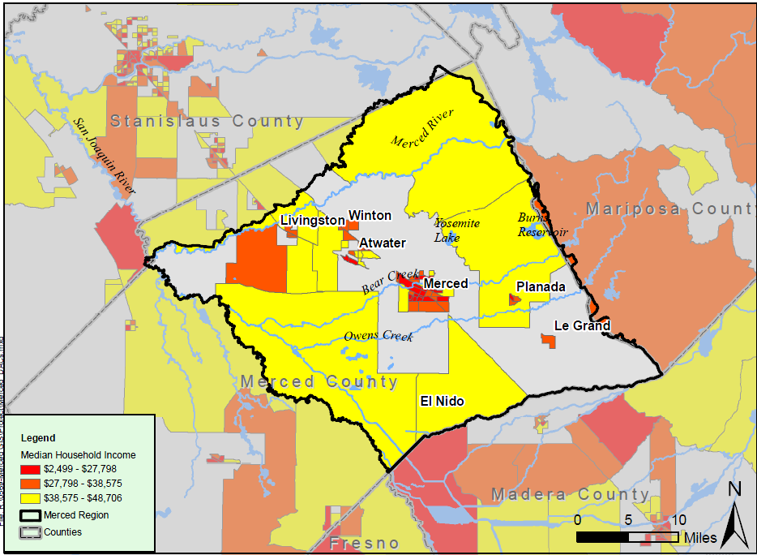

Culture and Diversity
The Region has a well-established and growing Hispanic/Latino population, which constitutes the largest single ethnic group in Merced County as well as each of the Region’s three incorporated cities (Merced County 2007). In addition, the Region has a substantial and growing Asian population that constituted approximately 17% of the City of Livingston in 2010 (US Census Bureau 2010).
Table 7: 2010 Ethnic Composition of the Region
City or Community | White | Hispanic/Latino | Asian | Other
City of Merced | 30.0% | 49.6% | 11.8% | 8.6%
City of Atwater | 35.8% | 52.6% | 5.0% | 6.6%
City of Livingston | 8.0% | 73.1% | 17.0% | 1.9%
County of Merced | 31.9% | 54.9% | 7.4% | 5.8%
California | 40.1% | 37.6% | 13.0% | 9.3%

Major Water Related Objectives and Conflicts
The Region’s greatest objective is to undertake processes necessary to develop an Integrated Regional Water Management Plan that will be a useful future guide to the Region. This objective was established through the extensive IRWM stakeholder group, which have largely expressed support for the fundamental concepts of the IRWM Program. As part of this process, the Region has identified major water-related conflicts and objectives, which will guide the IRWM Program as it moves forward. The following sections provide an overview of the Region’s existing objectives and conflicts (MAGPI 2010).

Stakeholder Outreach
TO BE ENHANCED FOLLOWING DEVELOPMENT OF SECTION 14: STAKEHOLDER INVOLVEMENT
There is widespread consensus throughout the Merced IRWM region that a comprehensive, adopted Merced IRWM Plan can only be achieved utilizing a rich and varied outreach strategy.
There is common understanding and agreement that the entities conducting this outreach are absolutely critical to advancing the progress of the MIRWMP. The Plan will require the services of highly-skilled facilitators experienced and effective in meeting facilitation, conflict resolution, and consensus building.
Therefore, one of the primary objectives of the Region is to implement the robust stakeholder outreach plan developed for the Region. For more information refer to Section 14: Stakeholder Involvement.

Climate Change Analysis
Merced County’s air quality is among the nation’s worst. According to the American Lung Association’s annual State of the Air report for 2004, Merced County is the 8th most ozone-polluted County in the nation. Merced County exceeds the state and federal standards for the air pollutants ozone and particulate matter sized 10 microns or greater (PM-10). The Federal Clean Air Act and the California Clean Air Act require areas that are designated non-attainment to reduce emissions until standards are met.
Local transportation planning and land use planning efforts have developed a number of climate change response actions, including low impact development and other innovations in order to achieve reductions in greenhouse gas emissions and related benefits. In particular, the City of Merced has made considerable strides in resource efficiency and reductions in greenhouse gas emissions through use of its 1997 General Plan, specific plans, and development codes.
Regional water planning in the Merced IRWM will benefit from inclusion of a Climate Change Analysis element in its Merced IRWM Plan, both for purposes of water resources planning, and to address other regional concerns associated with air pollution.

Expand Environmental Stewardship
The East Merced Resource Conservation District is known throughout the Merced IRWM region for its interest in watershed coordination and its continued stewardship of the Merced River watershed.
The Merced IRWM Program is dedicated to furthering environmental stewardship efforts initiated by EMRCD by considering environmental stewardship projects for inclusion in the final MIRWMP, and taking advantage of efficiencies by coordinating with additional interested stakeholders.
The MIRWMP will coordinate this focus in environmental stewardship and climate change with the resources of the University of California Merced, a leader in climate change research.

Flood Management
TO BE REVISED BASED ON INTEGRATED FLOOD STUDY
Flood management has always been a source of concern for the Merced IRWM region, and as demonstrated within Section 1.3.7, there are many flood hazard zones within the Region.
The Region has experienced two major flood events in recent years (2006 and 1998), which prompted hundreds of lawsuits for damages due to structural damage to private homes. In addition, the flooding caused substantial structural damage to area bridges and roads as well as geomorphic impacts to creeks.
During stakeholder meetings regarding any matter related to water or land use planning, flood management is consistently ranked as a very high priority, and this issue will continue to be an important issue in IRWM planning for the Region.

Salinity and Nutrients in Groundwater & Surface Waters
TO BE REVISED BASED ON SALT AND NUTRIENT STUDY
As described previously, many constituents are of concern to groundwater quality in the Region. The Region has many known and unknown sources of pollution, and has particular concern for sources of salts (TDS) and nutrients that affect groundwater and surface water quality, supply, and reliability.
Effective salinity and nutrient management is necessary when integrating comprehensive water management strategies, including water conservation. High salinity and other compounds can decrease the effectiveness and durability of water delivery, conveyance and treatment systems. The Merced County Division of Environmental Health has participated in salt and nutrient management at the local, regional and statewide levels, and increased involvement in the Central Valley Salinity Alternatives for Long Term Sustainability (CV-SALTS) coalition.
The MIRWMP is committed to expanding salinity and nutrient management efforts by increasing the Region’s knowledge base on the subject, determining local data management needs related to salinity and nutrient management, and establishing local objectives to address salinity and nutrient management concerns. The Region will also integrate and coordinate its salinity and nutrient management efforts with adjoining IRWM areas. The region is particularly interested in enhancing education and awareness related to:
- Animal confinesment and nutrition
- Salt and nutrient concentrations in feed to control excretion rates
- Land application of salt and nutrients at agronomic rates and times
- Best management practices (BMPs) related to irrigation to reduce salt and nutrient leaching and transport to groundwater and surface waters
- BMPs associated with reducing salinization of soil, affecting long-term crop productivity
- BMPs to reduce the importation of excess salts and marco nutrients
- BMPs and development of tools to plan, quantify, and visualize salt and nutrient application to crop land

Climate Change
TO BE REVISED BASED ON CLIMATE CHANGE STUDY
The USEPA defines climate change as any significant change in the measures of climate lasting for an extended period of time. As such, climate change includes major changes in temperature, precipitation, or wind patterns, among other effects, that occur over several decades or longer. Greenhouse gases (GHGs) are directly linked to climate change, as these types of gases, which are also often air pollutants, have the ability to absorb and emit solar radiation.
DWR has documented impacts that climate change has had on water resources throughout California, including reduced snowpack levels, sea level rise, and changes in river flows. According to the California Water Plan 2009 Update (DWR 2009), California could be facing a significant water crisis exacerbated by climate change. The following list describes possible anticipated changes in the regional water cycle (DWR 2009):
- Decreases in snowfall could result from climate change increasing air temperatures, which would inhibit snow fall conditions to form;
- Decreased snowfall could lead to a reduction in snowpack size. Water supply availability would potentially change, because a less substantial snowpack would result in less snow melt, thereby reducing water sources;
- Water supply availability could also change if atmospheric temperatures reduce glaciers sooner than expected;
- Earlier peak stream flow due to climatic shifts (earlier melting periods) has the potential of impacting water supply, fisheries, and recreation activities. In the U.S. warming has occurred earlier in the winter season and into the spring, causing natural water flows to occur at higher intensities, which leaves the late spring and early summer with reduced water availability;
- Runoff/recharge volumes could be significantly reduced in the late spring and summer months because of the onset of warmer atmospheric pressures from climate change earlier in the winter season;
- Increased water usage could occur in summer months when warmer temperatures arrive and water availability has been reduced significantly due to earlier melting;
- Regions could be more susceptible to severe droughts as water supplies are over-utilized, and climate change worsens drought conditions;
- Water losses could be felt region-wide if higher air temperatures lead to increased evaporation rates in water bodies. This could also exacerbate drought conditions; and
- The frequency and intensity of floods can potentially increase in late winter and early spring as a consequence of early melting and inundation of early water supplies to the region.
As described in Section 16: Climate Change, a vulnerability analysis has been conducted to determine potential climate change impacts that could occur within the Region in accordance with guidelines set forth by DWR pertaining to development of IRWM Plans.

Legislative and Policy Context
Considering the potential water resources-related impacts that could occur throughout California and within the Region, DWR’s IRWM Grant Program Guidelines seek to ensure that IRWM Plans describe and consider the effects of climate change. Below is a summary of State legislation and policy that were considered as part of this IRWM Plan.

Executive Order (EO) S-3-05
EO S-3-05, signed on June 1, 2005, is one of the key pieces of legislation that has laid the foundation for California’s climate change policy. This piece of legislation recognizes California’s vulnerability to the impacts of climate change, which includes its water-related natural resources. EO S-3-05 established three GHG reduction targets for California:
- By 2010, reduce GHG emissions to 2000 California levels
- By 2020, reduce GHG emissions to 1990 California levels
- By 2050, reduce GHG emissions to 80 percent below 1990 California levels
In addition to establishing GHG reduction targets for California, EO S-3-05 dictates the head Secretary of the California Environmental Protection Agency (CalEPA) to establish the Climate Action Team (CAT) for State agencies to coordinate oversight of efforts to meet these targets. As laid out in the EO, the CAT has submitted biannual reports to the governor and State legislature describing progress made toward reaching the targets.
There are currently 12 sub-groups within CAT, one of which is the Water-Energy group (also known as WET-CAT). WET-CAT was tasked with coordinating the study of GHG effects on California’s water supply system, including the development of GHG mitigation strategies for energy consumption related to water use. Since the adoption of the AB 32 Scoping Plan (see discussion below), WET-CAT has been working on the implementation and analyses of six water-related measures identified in the Scoping Plan: Water Use Efficiency, Water Recycling, Water System Energy Efficiency, Re-use Urban Runoff, Increase Renewable Energy Production, and Public Goods Charge for Water.

Assembly Bill 32: The California Global Warming Solutions Act of 2006
Assembly Bill 32 (AB 32), the California Global Warming Solutions Act of 2006, is a piece of legislation that has laid the foundation for the State’s response to climate change. In 2006, AB 32 was signed by Governor Schwarzenegger to codify the mid-term GHG reduction target established in EO S-3-05 (reduce GHG emissions to 1990 levels by 2020). AB 32 directed the California Air Resources Board (CARB) to develop discrete early actions to reduce GHGs by 2007, and to adopt regulations to implement those early action measures by January 1, 2010.

Climate Change Scoping Plan
AB 32 required CARB to prepare a Scoping Plan to identify and achieve reductions in GHG emissions in California. The approved Climate Change Scoping Plan, which was adopted by CARB in December 2008, recommends specific strategies for different business sectors, including water management, to achieve the 2020 GHG emissions limit.

Senate Bill 97
Senate Bill 97 (SB 97) directed the Governor’s Office of Planning and Research (OPR) to develop amendments to the CEQA Guidelines to determine how climate change is analyzed in documents required under the California Environmental Quality Act (CEQA). On December 31, 2009, the Natural Resources Agency adopted amendments to the CEQA Guidelines and sent them to the California Office of Administrative Law for approval and filing with the Secretary of State (http://www.ceres.ca.gov/ceqa/guidelines/). The CEQA Guidelines are not prescriptive; rather they encourage lead agencies to consider many factors in performing a CEQA analysis, and maintain discretion with lead agencies to make their own determinations based on substantial evidence.

Managing an Uncertain Future: Climate Change Adaptation Strategies for California’s Water
DWR, in collaboration with the State Water Resources Control Board (SWRCB), other state agencies, and numerous stakeholders, has initiated a number of projects to begin climate change adaptation planning for the water sector. In October 2009, DWR released the first state-level climate change adaptation strategy for water resources in the U.S., and the first adaptation strategy for any sector in California. Entitled Managing an Uncertain Future: Climate Change Adaptation Strategies for California’s Water, the report details how climate change is currently affecting the state’s water supplies, and sets forth ten adaptation strategies to help avoid or reduce climate change impacts to water resources.
Central to these adaptation efforts will be the full implementation of IRWM plans, which address regionally-appropriate management practices that incorporate climate change adaptation. These plans will evaluate and provide a comprehensive, economical, and sustainable water use strategy at the watershed level for California.

Executive Order S-13-08
Given the potentially serious threat of sea level rise to California's water supply and coastal resources, and the subsequent impact it would have on our state's economy, population, and natural resources, Governor Schwarzenegger issued EO S-13-08 to enhance the state's management of climate impacts from sea level rise, increased temperatures, shifting precipitation, and extreme weather events.

California Climate Adaptation Strategy
In response to the passage of EO S-13-08, the Natural Resource Agency wrote the report entitled 2009 California Climate Adaptation Strategy (CAS), to summarize the best known science on climate change impacts in the state, to assess vulnerability, and to outline possible solutions that can be implemented within and across the state agencies to promote resilience to climate change.

GHG Reporting Rule
While California has taken the lead in climate change policy and legislation, there have been several recent important developments at the federal level. On September 22, 2009, USEPA released its final GHG Reporting Rule (Reporting Rule). Starting in 2010, facility owners that emit 25,000 metric tons of CO2e or more per year are required to submit an annual GHG emissions report with detailed calculations of facility GHG emissions. These activities will dovetail with the AB 32 reporting requirements in California.

References
California Department of Water Resources (DWR). 2004. California’s Groundwater Bulletin 118 – San Joaquin Valley Groundwater Basin, Merced Subbasin. February 2004.
California Department of Water Resources (DWR). 2009. California Water Plan Update 2009. Available: http://www.waterplan.water.ca.gov/cwpu2009/index.cfm
Chowchilla Water District. Chowchilla Water District Water System. Available: http://cwdwater.com/index.php/about-cwd-2/district-system. Accessed June 5, 2012.
City of Atwater. 2006. City of Atwater 2005 Urban Water Management Plan (Administrative Draft). April 2006.
City of Livingston. 2007. City of Livingston 2005 Urban Water Management Plan. March 2007.
City of Livingston. 2008. City of Livingston 2025 General Plan. October 2008.
City of Merced. 2011. City of Merced 2010 Urban Water Management Plan. June 2011.
East Merced Resource Conservation District (EMRCD). N.D. Available: http://emrcd.org/EMRCD/board.htm. Accessed June 6, 2012.
East Merced Resource Conservation District (EMRCD). 2008. Final Report for the Merced River Alliance Project. September 2008.
Federal Emergency Management Agency. 2010. FEMA Flood Zones. Available: http://www.fema.gov/plan/prevent/floodplain/nfipkeywords/flood_zones.shtm. Accessed June 6, 2012.
Merced Area Groundwater Pool Interest (MAGPI). 2002. Data Assessment Report for the Merced Groundwater Basin. August 2002.
Merced Area Groundwater Pool Interest (MAGPI). 2008. Merced Groundwater Basin Groundwater Management Plan Update. July 2008.
Merced Area Groundwater Pool Interest (MAGPI). 2009. Merced Integrated Regional Water Management Plan Region Acceptance Process Application. April 2009.
Merced Area Groundwater Pool Interest (MAGPI). 2010. Merced Integrated Regional Water Management Plan – Proposal for Planning Funds. September 2010.
Merced County. 2007. Merced County General Plan Public Review Draft Background Report. June 2007.
Merced County Local Agency Formation Commission. 2007. Final Report – County of Merced Water and Sewer Service Providers Municipal Service Review. May 2007.
Merced Irrigation District. 2003. Merced Irrigation District AB3616 Water Management Plan. May 2003.
Merced Storm Water Group. 2007. Storm Water Management Program. April 2007
San Luis & Delta-Mendota Water Authority (SLDMWA). 2011. San Luis & Delta-Mendota Water Authority Member Agencies. Available: http://www.sldmwa.org/member_districts.htm. Accessed June 8, 2012.
United States Census Bureau. 2010. State and County QuickFacts – Merced County. Available: http://quickfacts.census.gov/qfd/states/06/06047.html. Accessed June 6, 2012.
United States Environmental Protection Agency (USEPA). 2012. List of Contaminants and their MCLs. Available: http://water.epa.gov/drink/contaminants/index.cfm. Accessed June 7, 2012.

